XFUSION FusionDirector for vROps
2.0.2
User Guide
 | Date | 2022-06-30
 | Copyright © Copyright Holder. All rights reserved.

Notice
The information in this document is subject to change without notice. Every effort has been made in the preparation of this document to ensure accuracy of the contents, but all statements, information, and recommendations in this document do not constitute a warranty of any kind, express or implied.

Contents
About this Document v
1 Overview 7
2 Managing the vROps Plug-in 9
2.1 Installation 9
2.2 Uninstallation 12
2.3 Upgrade 14
3 Configuring FusionDirector 15
3.1 Addition 15
3.2 Modification 24
3.3 Deletion 27
4 Querying Server Information 29
4.1 Querying Servers 29
4.2 Querying Component Information 31
4.3 Querying Component Group Information 34
4.4 Querying Server Information 35
4.5 Querying Server Type Information 35
4.6 Querying the FusionDirector Information 36
5 Querying Enclosure Information 37
5.1 Querying Enclosures 37
5.2 Querying Component Information 38
5.3 Querying Component Group Information 41
5.4 Querying Enclosure Information 41
5.5 Querying the FusionDirector Information 42
6 Querying Dashboard Information 44
6.1 Querying the FusionDirector Overview Dashboard 44
6.2 Querying XFUSION Servers Overview Dashboard 44
6.3 Querying XFUSION Server Detailed Dashboard 48
6.4 Querying XFUSION Enclosure Overview Dashboard 49
6.5 Querying XFUSION Enclosure Detailed Dashboard 50
7 Viewing Alerts 52
8 Querying the XFUSION vROps Plug-in Version 54
A Obtaining Technical Support 55
B Communication Matrix 56

About this Document
Overview
This guide describes how to install and maintain the vRealize Operations Manager (vROps) plug-in.
Intended Audience
This guide is intended for:
- Technical support engineers
- System maintenance engineers
Symbol Conventions
The symbols that may be found in this document are defined as follows.
Symbol | Description
 | Indicates an imminently hazardous situation which, if not avoided, will result in death or serious injury.
 | Indicates a potentially hazardous situation which, if not avoided, could result in death or serious injury.
 | Indicates a potentially hazardous situation which, if not avoided, may result in minor or moderate injury.
Indicates a potentially hazardous situation which, if not avoided, could result in equipment damage, data loss, performance deterioration, or unanticipated results.
NOTICE is used to address practices not related to personal injury.
Calls attention to important information, best practices, and tips.
NOTE is used to address information not related to personal injury, equipment damage, and environment deterioration.

Change History
Changes between document issues are cumulative. The latest document issue contains all the changes made in earlier issues.
Issue | Date | Description
01 | 2022-06-30 | The issue is the first official release.

Overview
Function Description
The FusionDirector for vROps plug-in can be used to manage and monitor servers. Only vRealize Operations Manager 8.0 and 8.1 are supported. This document uses vRealize Operations Manager 8.1 as an example.
The FusionDirector for vROps plug-in provides the following functions:
- Query the basic information about severs and enclosures (also referred to as chassis).
- Query the alert information about severs and enclosures.
- Query the health status of severs and enclosures.
- Query statistics about the FusionDirector, severs, and enclosures using the dashboard.
Servers supported by the FusionDirector for vROps plug-in
Table Servers supported by the FusionDirector for vROps plug-in. lists servers supported by the FusionDirector for vROps plug-in.
                - Servers supported by the FusionDirector for vROps plug-in.
Type | Server Model
Rack | 1288H V5
Rack | 2288H V5
Rack | 2488 V5
Rack | 2488H V5
Rack | 8100 V5
Rack | RH2288H V3
Rack | 1288H V6
Rack | 2288H V6
Blade | CH121 V5
Blade | CH242 V5
Blade | CH121 V3
Blade | CH242 V3
Chassis | E9000 (MM920)

Matching Versions
Software | Matching Versions
FusionDirector | FusionDirector: 1.6.0.SPC1  FusionDirector: 1.6.1.SPC2  FusionDirector: 1.7.0  FusionDirector: 1.7.1.SPC2

Managing the vROps Plug-in
2.1 Installation
2.2 Uninstallation
2.3 Upgrade

Installation
Prerequisites
You have obtained the vROps plug-in software package and verified its integrity.
            - Obtain the vROps plug-in software package (for example, XFUSION_FusionDirector_For_vROps_2.0.2.zip) and its SHA256 verification file (for example, XFUSION_FusionDirector_For_vROps.sha256_2.0.2.sum) from GitHub.
            - Verify the integrity of the vROps plug-in software package(on Linux).
- Go to the directory where the plug-in installation package and SHA256 verification file are stored.
- Run the sha256sum -c < (grep software package name sha256 verification file name) command to verify the software package.
Example: sha256sum -c <(grep XFUSION_FusionDirector_For_vROps_2.0.2.zip XFUSION_FusionDirector_For_vROps_2.0.2.sha256.summ)
- Check whether the verification result is OK.
- If yes, the software package has not been tampered with and can be used.
- If no, the software package has been tampered with. Obtain a new software package.
----End
Procedure
Install the vROps plug-in.
            - Decompress the installation package.
Obtain the installer, such as XFUSIONFusionDirectorManagementPack_X.X.X.pak.
            - On the vROps WebUI, choose Administration.
The Administration page is displayed.
            - In the navigation pane on the left, choose Repository.
The Repository page is displayed.
            - In the lower part of the page, click ADD/UPGRADE.
The Add Solution dialog box is displayed, as shown in Figure Add Solution.
              - Add Solution
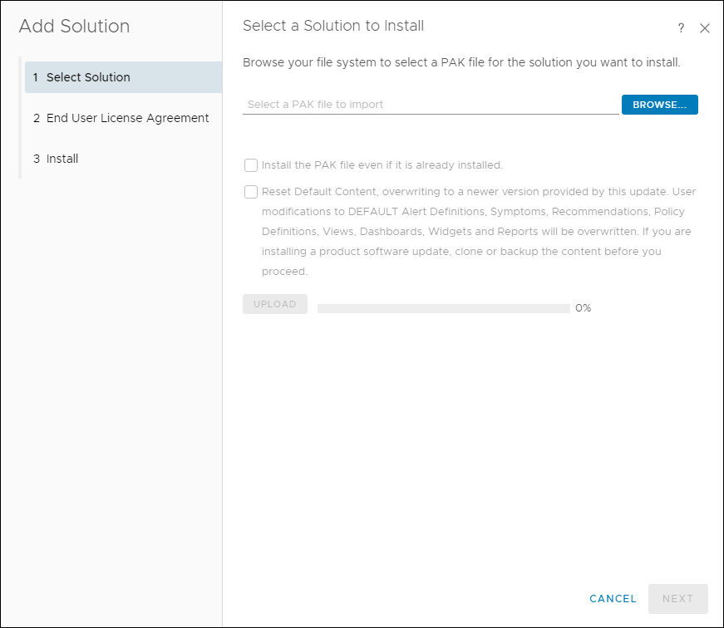

            - On the Select Solution tab page, click BROWSE and select the plug-in installation file.
            - (Optional) Select Install the PAK file even if it is already installed.
            - Click UPLOAD and upload the installation file.
            - Click NEXT.
The Confirmation dialog box is displayed.
            - Click Yes.
The End User License Agreement tab page is displayed, as shown in Figure End User License Agreement.
              - End User License Agreement
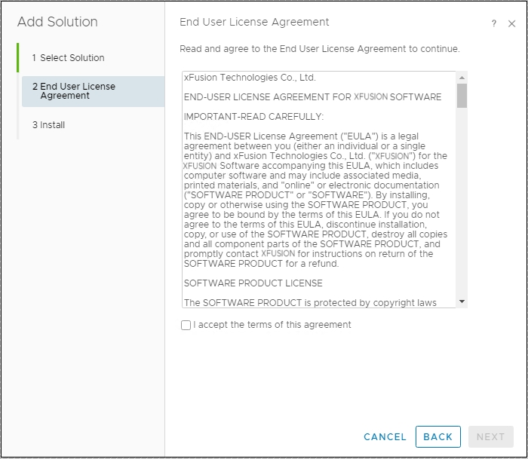

            - Select I accept the terms of this agreement and click NEXT.
The Installation tab page is displayed.
            - After the installation is complete, click FINISH.
In the lower part of the Repository page, view the installed vROps plug-in, as shown in Figure Viewing the installed vROps plug-in.
              - Viewing the installed vROps plug-in
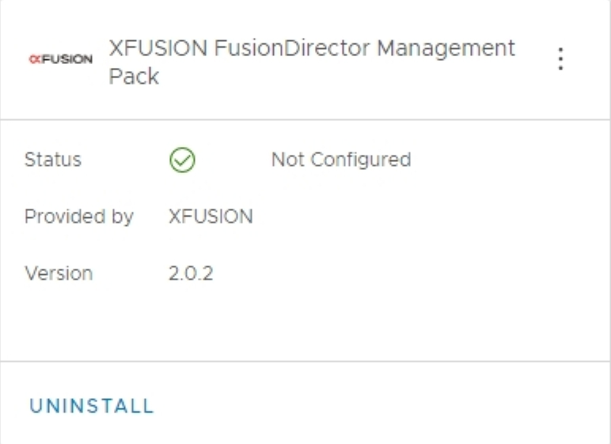

----End

Uninstallation
            - On the vROps WebUI, choose Administration.
The Administration page is displayed.
            - In the navigation pane on the left, choose Repository.
The Repository page is displayed.
            - In the lower part of the page, select the vROps plug-in to be uninstalled and click UNINSTALL, as shown in Figure 2-4.
              - Uninstalling the vROps plug-in
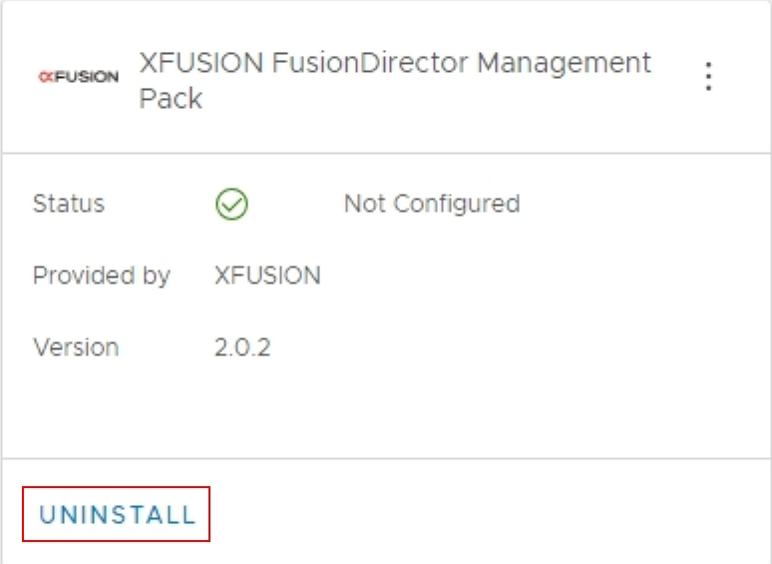

The Warning dialog box is displayed, as shown in Figure 2-5.
              - Warning dialog box
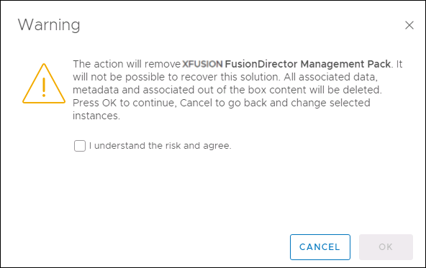

            - Select I understand the risk and agree. and click OK.
The vROps plug-in is uninstalled.
----End

Upgrade
Procedure
            - (Optional) Uninstall the vROps plug-in of the earlier version. For details, see 2.2 Uninstallation.
            - Install the vROps plug-in of the new version. For details, see 2.1 Installation.
----End

Configuring FusionDirector
3.1 Addition
3.2 Modification
3.3 Deletion

Addition
            - On the vROps WebUI, choose Administration.
The Administration page is displayed.
            - In the navigation tree on the left, choose Other Accounts.
The Other Accounts page is displayed.
            - Click ADD ACCOUNT.
            - Select the type of the account to be added, for example, FusionDirectorAdapter.
The New Account page is displayed, as shown in Figure 3-1.
              - New Account
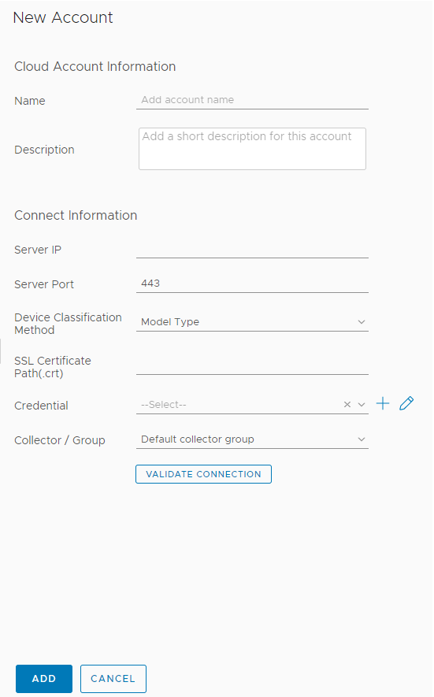

            - Set the following parameters:
- Name: user-defined name to identify different FusionDirector instances
- Description: (optional) user-defined description to describe a FusionDirector instance
- Server IP: FusionDirector IP address
- Server Port: FusionDirector port number, which is 443 by default.
- Device Classification Method: way to classify servers
- Model Type: type view
- Group Type: group view
- SSL Certificate Path(.crt): (optional) path of the certificate in the vROps


You are advised to upload the SSL certificate for security. For details about how to upload the certificate, see Step 6 to Step 7.
            - (Optional) Obtain the certificate.
- Access the FusionDirector WebUI.
- Click Certificate error in the address box of the browser.
The Certificate Invalid dialog box is displayed, as shown in Figure 3-2.
              - Invalid certificate
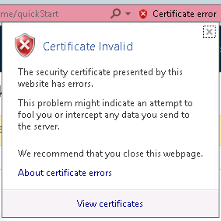

- Click View certificates.
The Certificate dialog box is displayed.
- Click the Details tab.
The Details tab is displayed, as shown in Figure 3-3.
              - Details
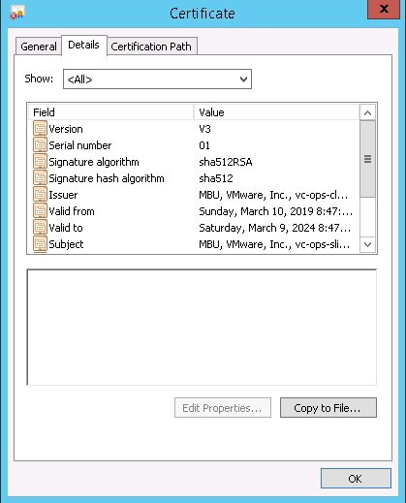

- Click Copy to File....
The Certificate Export Wizard is displayed, as shown in Figure 3-4.
              - Certificate Export Wizard
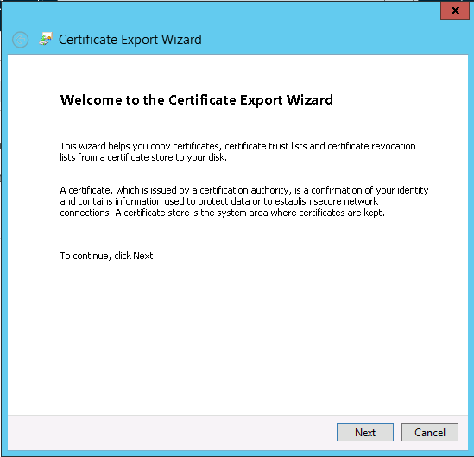

- Click Next. In the Certificate Export Wizard dialog box, select DER encoding binary X.509 (.CER), as shown in Figure 3-5.
              - Setting the format of files to be exported
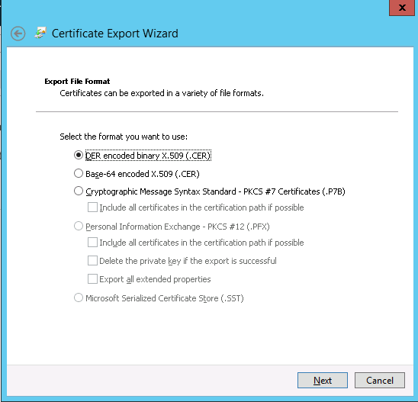

- Click Next. In the Certificate Export Wizard dialog box, click Browse..., select the certificate export path, and enter the certificate file name, as shown in Figure 3-6.
              - Service certificate
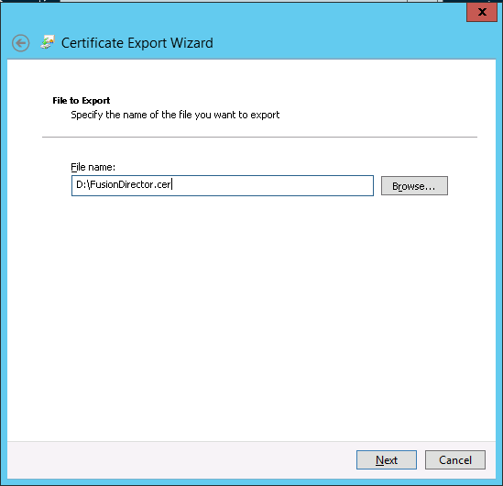

- Click Next to complete certificate export.
            - (Optional) Import the certificate file to the vROps backend.
- Configure the SSH access permission for the vROps.
  - The vROps backend is displayed, as shown in Figure 3-7.
              - vROps backend
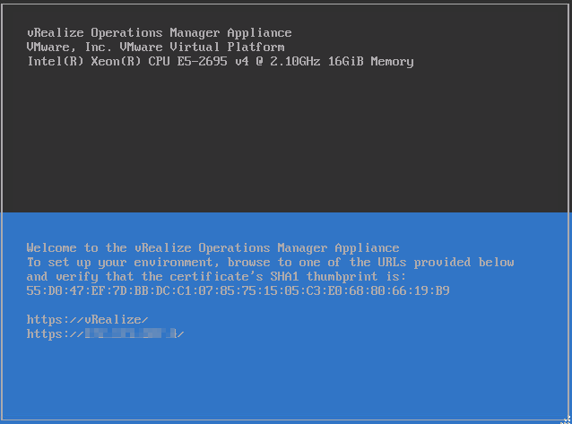

  - Press Alt+F1 and enter the username and password to log in to the vROps, as shown in Figure 3-8.

- The username is root and the initial password is blank.
- When you log in for the first time, you need to change the initial password, press Enter, enter previous and new passwords, and confirm the new password. The new password must contain uppercase letters, lowercase letters, digits, and special characters.
              - Logging in to the vROps
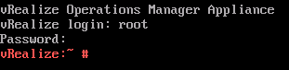

  - Run the vi /etc/ssh/sshd_config command to edit the configuration file sshd_config.
Change the value of MaxSession to 20 and the value of AllowTcpForwarding to yes.
  - Run the service sshd start command to start the SSHD service.
  - Run the chkconfig sshd on command to enable the SSHD service.
  - Run the service vmware-vcops-firewall stop command to disable the firewall.
  - Run the chkconfig vmware-vcops-firewall off command to disable the firewall upon startup.
- Use the SSH tool to upload the certificate file to /usr/lib/vmware-vcops/user/plugins/inbound.
- Enter the SSL certificate path /usr/lib/vmware-vcops/user/plugins/inbound/FusionDirector.crt in Step 5.
            - In the Credential field, click .
The Manage Credentials dialog box is displayed, as shown in Figure 3-9.
              - Manage Credentials
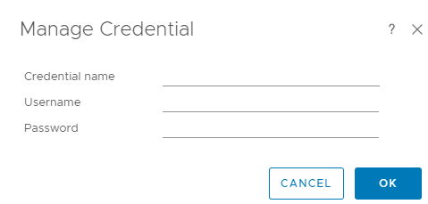

            - Set the following parameters and click OK.
- Credential name: user-defined name to identify different credentials
- Username: FusionDirector username to access the Redfish API. The default username is rootRedfish.
- Password: FusionDirector password to access the Redfish API. The default password is Machine@123.
            - Click VALIDATE CONNECTION.
If the test connection is successful, a dialog box is displayed, as shown in Figure 3-10. Click OK. If the test connection fails, the failure cause is displayed. Modify the FusionDirector information as prompted.
              - Successful test connection
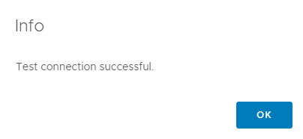

            - Click ADD.
The FusionDirector instance is added.
On the Other Accounts page, view the added FusionDirector instance, as shown in Figure 3-11.
              - Viewing the added account
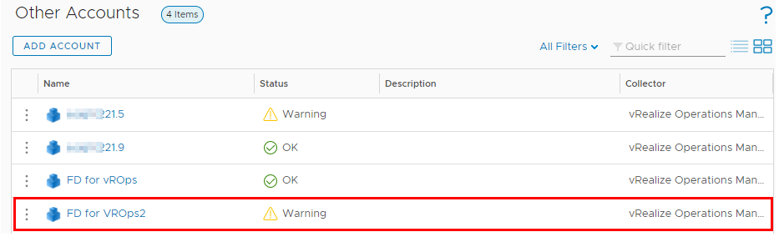

----End

Modification
            - On the vROps WebUI, choose Administration.
The Administration page is displayed.
            - In the navigation tree on the left, choose Other Accounts.
The Other Accounts page is displayed, as shown in Figure 3-12.
              - Other Accounts
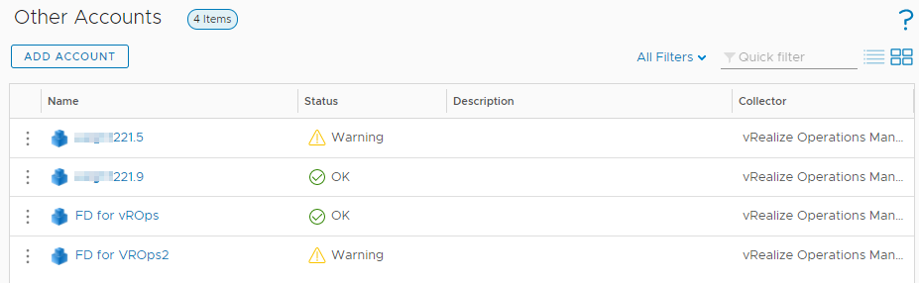

            - Click the name of the FusionDirector instance to be modified, for example, FD for vROps.
The FusionDirector information page is displayed, as shown in Figure 3-13.
              - FusionDirector information page
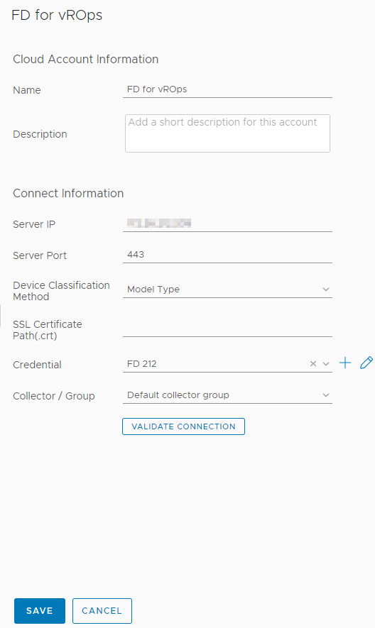

            - Modify the following parameters as required:
- Display name: user-defined name to identify different FusionDirector instances
- Description: (optional) user-defined description to describe a FusionDirector instance
- Server IP: FusionDirector IP address
- Server Port: FusionDirector port number, which is 443 by default.
- Device Classification Method: way to classify servers
- Model Type: classify servers by type
- Group Type: classify servers by group
- SSL Certificate Path(.crt): (optional) path of the certificate in the vROps
- Credential: Click to change the credential name, username, and password.
If the FusionDirector port number, username, or password is changed after the FusionDirector connection, you need to synchronize the new port number, user name, or password to the FusionDirector. Otherwise, server management is affected.
            - Check whether the information in the Connect Information area is modified.
- If yes, click VALIDATE CONNECTION.
If the test connection is successful, a dialog box is displayed. Click OK. If the test connection fails, the failure cause is displayed. Modify the FusionDirector information as prompted.
- If no, go to Step 6.
            - Click SAVE.
The Other Accounts page is displayed. You can view the modified FusionDirector information.
----End

Deletion
            - On the vROps WebUI, choose Administration.
The Administration page is displayed.
            - In the navigation tree on the left, choose Other Accounts.
The Other Accounts page is displayed, as shown in Figure 3-14.
              - Other Accounts

            - Click next to the name of the FusionDirector instance to be deleted.
The operation selection list is displayed.
            - Click Delete.
A confirmation dialog box is displayed, as shown in Figure 3-15.
              - Deletion confirmation dialog box
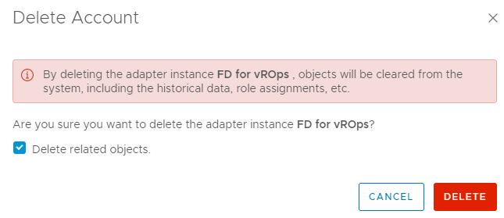

            - Select Delete related objects. (which is selected by default) and click DELETE.
The FusionDirector instance is deleted.
----End

Querying Server Information
4.1 Querying Servers
4.2 Querying Component Information
4.3 Querying Component Group Information
4.4 Querying Server Information
4.5 Querying Server Type Information
4.6 Querying the FusionDirector Information

Querying Servers
            - On the vROps WebUI, choose Environment.
The Environment page is displayed.
            - In the navigation pane, choose XFUSION FusionDirector Management Pack > XFUSION Servers.
The XFUSION Servers page is displayed.
            - In the navigation pane, view the list of all servers, as shown in Figure 4-1 and Figure 4-2.
              - XFUSION servers by Model Type
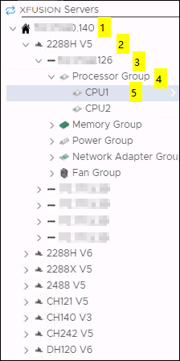

- 1: FusionDirector IP address
- 2: Server model
- 3: Server label and iBMC IP address. If no label is set for the server, only the iBMC IP address is displayed. For details about how to set the server label, see the FusionDirector Operation Guide.
- 4: Component group
- 5: A component
              - XFUSION servers by Group Type
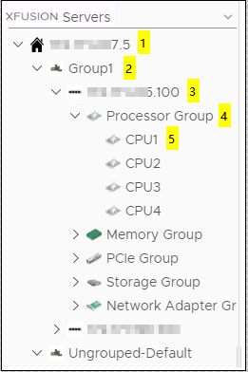

- 1: FusionDirector IP address
- 2: Server group name, which can be set in the FusionDirector. For details, see the FusionDirector Operation Guide.
- 3: Server label and iBMC IP address. If no label is set for the server, only the iBMC IP address is displayed. For details about how to set the server label, see the FusionDirector Operation Guide.
- 4: Component type
- 5: A component
----End

Querying Component Information
            - On the vROps WebUI, select Environment.
The Environment page is displayed.
            - In the navigation pane, choose XFUSION FusionDirector Management Pack > XFUSION Servers.
The XFUSION Servers page is displayed.
            - Select a FusionDirector IP address, a server model (by Group Type), a server, a component group, and a component, as shown in Figure 4-3.
              - Component information
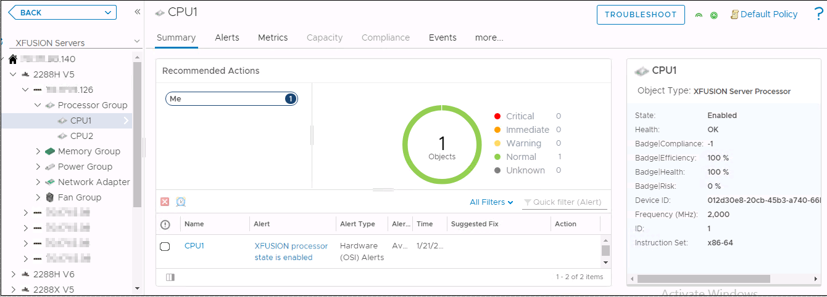

            - View the summary of the component.
- Click Summary.
The Summary page is displayed.
- In the Recommended Actions area, view the running status and alarm information about the component, as shown in Figure 4-4.
              - Viewing the summary
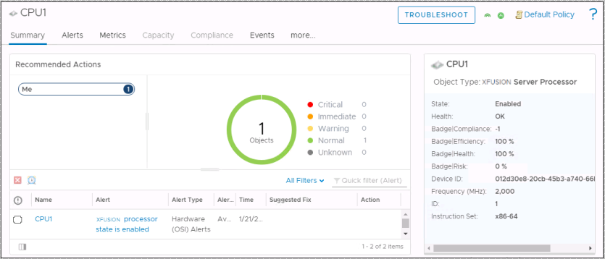

            - View warning information of the component.
- Click Alerts.
The Alerts page is displayed.
- Select a grouping mode, for example, Object Type.
- Click to expand the warning list.
- Click a warning name to view details about the warning.
              - Viewing warning information
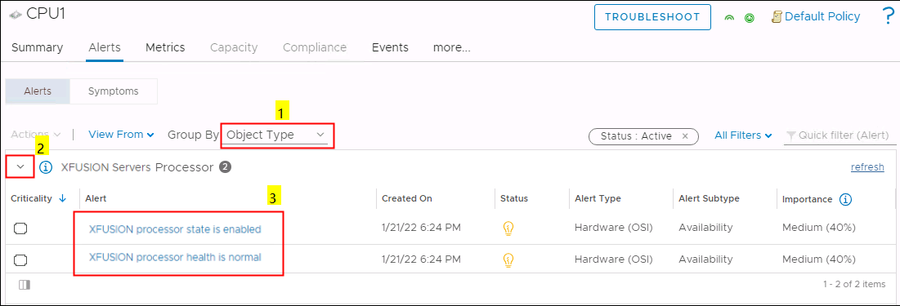

            - View the real-time status curve of the component.
- Click Metrics.
The Metrics page is displayed.
              - Metrics
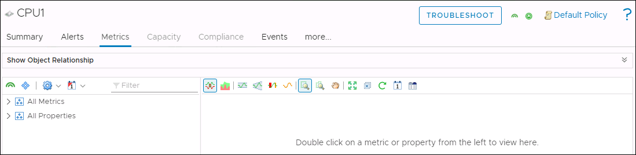

- Click to expand the information list under All Metrics or All Properties.
- Double-click the real-time status information to be viewed. For example, double-click Health, as shown in Figure 4-7.
You can view the real-time status curve in the right pane.
              - Viewing the real-time status curve
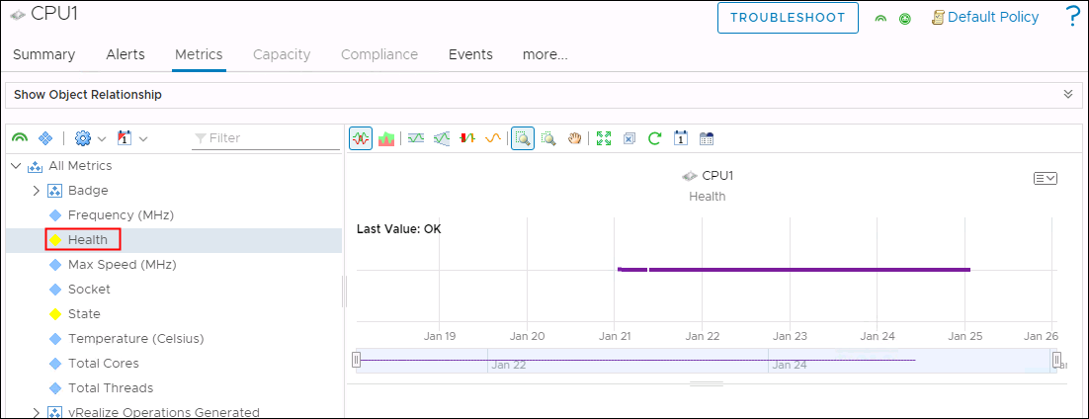

            - View details about a component view.
- Click more > Details.
The Details page is displayed.
- Select a view.
- View details about the view.
              - Viewing details about the view
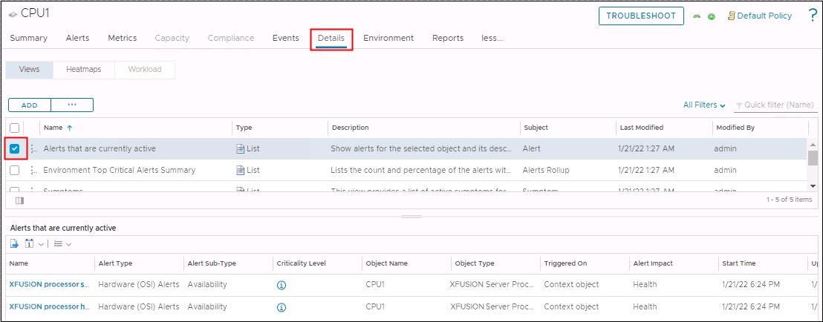

----End

Querying Component Group Information
            - On the vROps WebUI, choose Environment.
The Environment page is displayed.
            - In the navigation pane, choose XFUSION FusionDirector Management Pack > XFUSION Servers.
The XFUSION Servers page is displayed.
            - Select a FusionDirector IP address, a server model (by Group Type), a server, and a component group, as shown in Figure 4-9.
              - Component group information
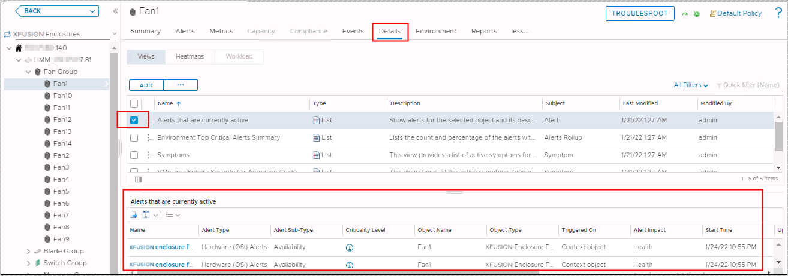

            - See 4.2 Querying Component Information to view the summary, warnings, details, and real-time status curves of all components in the component group.
----End

Querying Server Information
            - On the vROps WebUI, choose Environment.
The Environment page is displayed.
            - In the navigation pane, choose XFUSION FusionDirector Management Pack > XFUSION Servers.
The XFUSION Servers page is displayed.
            - Select a FusionDirector IP address, a server model (by Group Type), and a server, as shown in Figure 4-10.
              - Server information
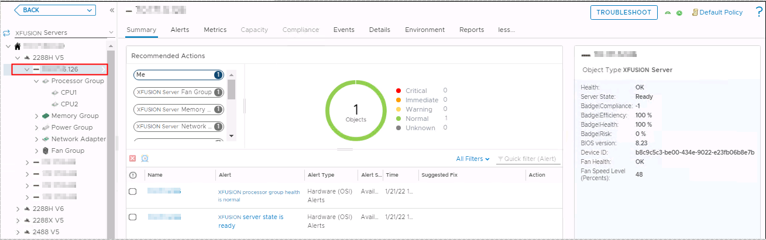

            - See 4.2 Querying Component Information to view the summary, warnings, details, and real-time status curves of all components of the server.
----End

Querying Server Type Information
            - On the vROps WebUI, choose Environment.
The Environment page is displayed.
            - In the navigation pane, choose XFUSION FusionDirector Management Pack > XFUSION Servers.
The XFUSION Servers page is displayed.
            - Select a FusionDirector IP address and a server model (by Group Type), as shown in Figure 4-11.
              - Server type
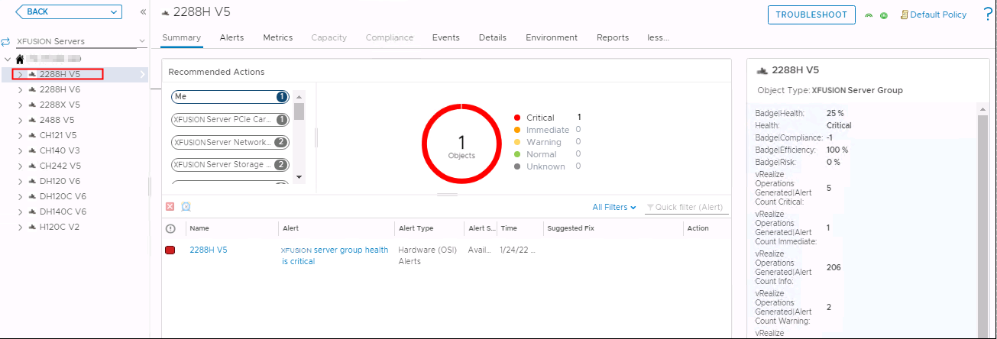

            - See 4.2 Querying Component Information to view the summary, warnings, details, and real-time status curves of all components of the server type.
----End

Querying the FusionDirector Information
            - On the vROps WebUI, choose Environment.
The Environment page is displayed.
            - In the navigation pane, choose XFUSION FusionDirector Management Pack > XFUSION Servers.
The XFUSION Servers page is displayed.
            - Select a FusionDirector IP address, as shown in Figure 4-12.
              - FusionDirector information
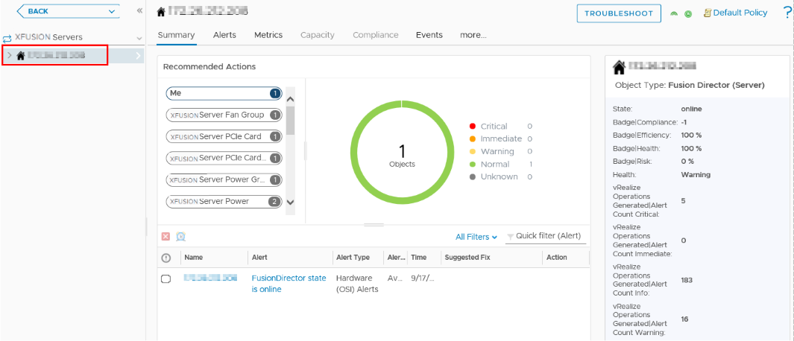

            - See 4.2 Querying Component Information to view the summary, warnings, details, and real-time status curves of all components of the FusionDirector instance.
----End

Querying Enclosure Information
5.1 Querying Enclosures
5.2 Querying Component Information
5.3 Querying Component Group Information
5.4 Querying Enclosure Information
5.5 Querying the FusionDirector Information

Querying Enclosures
            - On the vROps WebUI, choose Environment.
The Environment page is displayed.
            - In the navigation pane, choose XFUSION FusionDirector Management Pack > XFUSION Enclosures.
The XFUSION Enclosures page is displayed.
            - In the navigation pane, view the list of all enclosures, as shown in Figure 5-1.
              - XFUSION enclosures
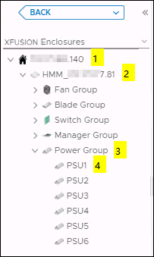

- 1: FusionDirector IP address
- 2: Enclosure name and iBMC IP address
- 3: Component group
- 4: A component
----End

Querying Component Information
            - On the vROps WebUI, choose Environment.
The Environment page is displayed.
            - In the navigation pane, choose XFUSION FusionDirector Management Pack > XFUSION Enclosures.
The XFUSION Enclosures page is displayed.
            - Select a FusionDirector IP address, an enclosure, a component group, and a component, as shown in Figure 5-2.
              - Component information
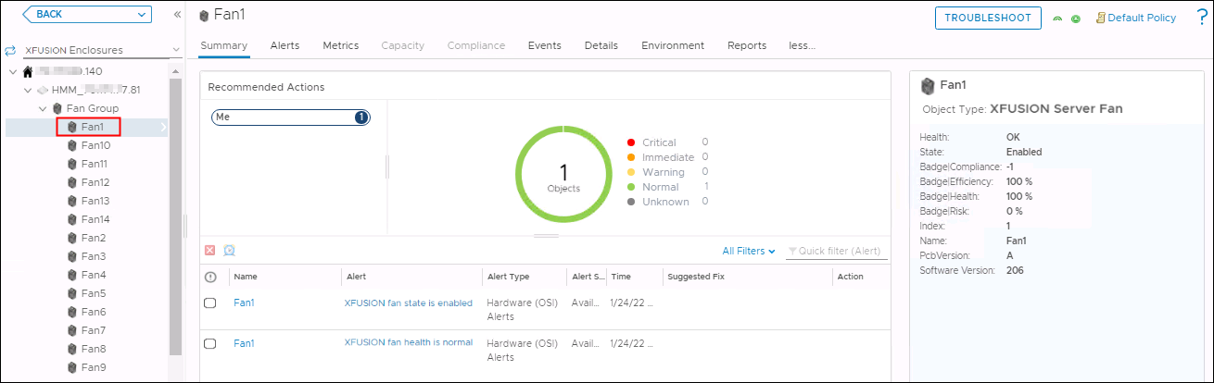

            - View the summary of the component.
- Click Summary.
The Summary page is displayed.
- In the Recommended Actions area, view the running status and alarm information about the component, as shown in Figure 5-3.
              - Viewing the summary
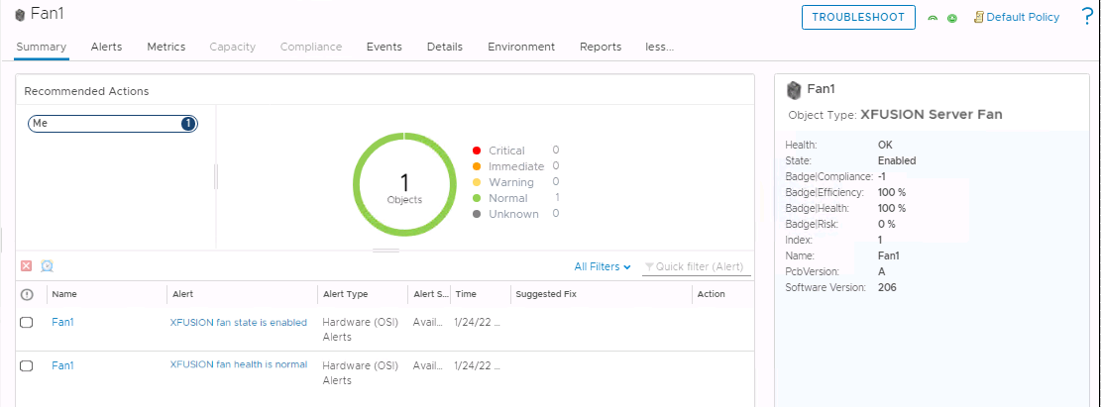

            - View warning information of the component.
- Click Alerts.
The Alerts page is displayed.
- Select a grouping mode, for example, Object Type.
- Click to expand the warning list.
- Click a warning name to view details about the warning.
              - Viewing warning information
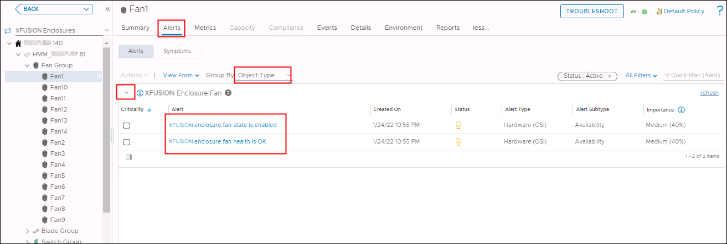

            - View the real-time status curve of the component.
- Click Metrics.
The Metrics page is displayed.
              - Metrics
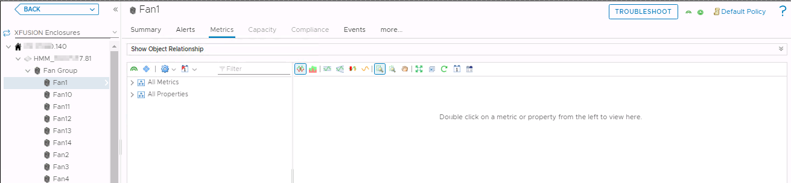

- Click to expand the information list under All Metrics or All Properties.
- Double-click the real-time status information to be viewed. For example, double-click Health, as shown in Figure 5-6.
You can view the real-time status curve in the right pane.
              - Viewing the real-time status curve
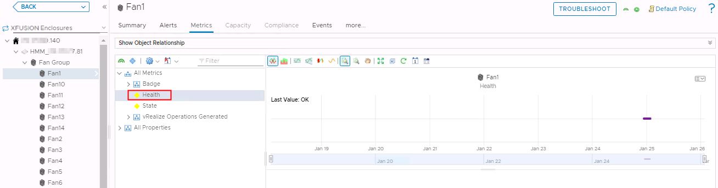

            - View details about a component view.
- Click more > Details.
The Details page is displayed.
- Select a view.
- View details about the view.
              - Viewing details about the view
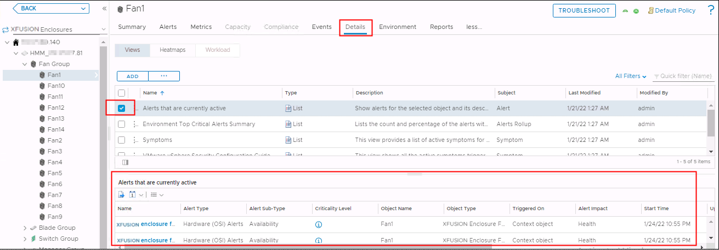

----End

Querying Component Group Information
            - On the vROps WebUI, choose Environment.
The Environment page is displayed.
            - In the navigation pane, choose XFUSION FusionDirector Management Pack > XFUSION Enclosures.
The XFUSION Enclosures page is displayed.
            - Select a FusionDirector IP address, an enclosure, and a component group, as shown in Figure 5-8.
              - Component group information
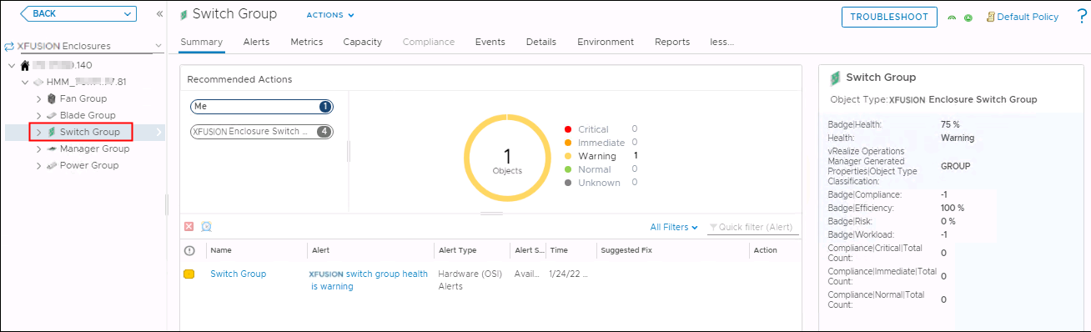

            - See 5.2 Querying Component Information to view the summary, warnings, details, and real-time status curves of all components in the component group.
----End

Querying Enclosure Information
            - On the vROps WebUI, choose Environment.
The Environment page is displayed.
            - In the navigation pane, choose XFUSION FusionDirector Management Pack > XFUSION Enclosures.
The XFUSION Enclosures page is displayed.
            - Select a FusionDirector IP address and an enclosure, as shown in Figure 5-9.
              - Enclosure information
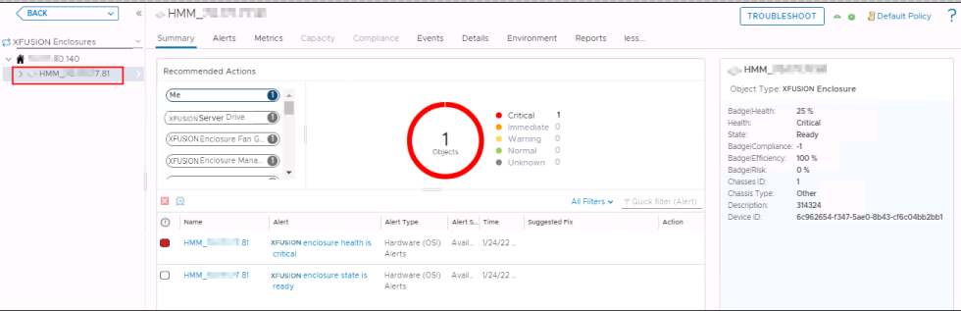

            - See 5.2 Querying Component Information to view the summary, warnings, details, and real-time status curves of all components of the enclosure.
----End

Querying the FusionDirector Information
            - On the vROps WebUI, choose Environment.
The Environment page is displayed.
            - In the navigation pane, choose XFUSION FusionDirector Management Pack > XFUSION Enclosures.
The XFUSION Enclosures page is displayed.
            - Select a FusionDirector IP address, as shown in Figure 5-10.
              - FusionDirector information
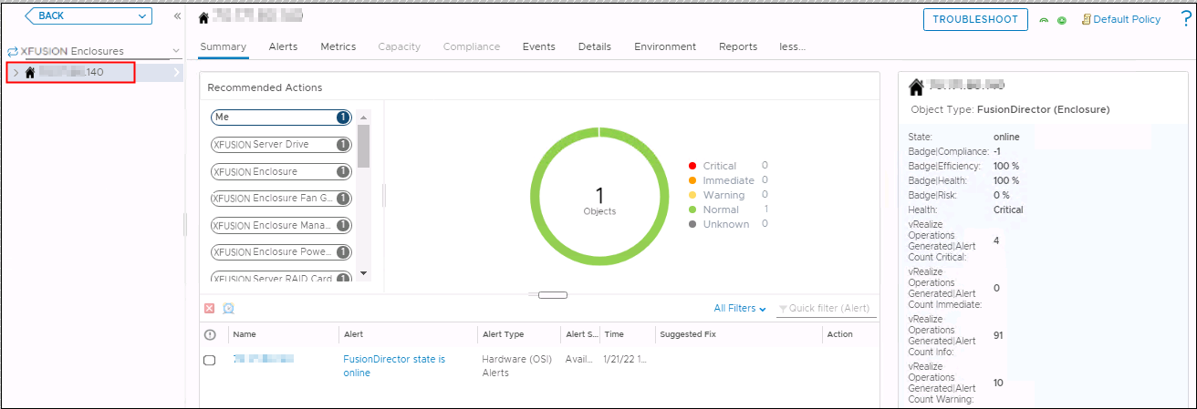

            - See 5.2 Querying Component Information to view the summary, warnings, details, and real-time status curves of all components of the FusionDirector instance.
----End

Querying Dashboard Information
6.1 Querying the FusionDirector Overview Dashboard
6.2 Querying XFUSION Servers Overview Dashboard
6.3 Querying XFUSION Server Detailed Dashboard
6.4 Querying XFUSION Enclosure Overview Dashboard
6.5 Querying XFUSION Enclosure Detailed Dashboard

Querying the FusionDirector Overview Dashboard
            - On the vROps WebUI, choose Dashboards.
The Dashboards page is displayed.
            - In the navigation pane, choose Dashboards > Fusion Director Overview Dashboard.
The Fusion Director Overview Dashboard page is displayed.
You can view the FusionDirector name, adapter type, object type, policy, collection state, collection status, server IP address, port, state, FusionDirector version, and classification method, as shown in Figure 6-1.
              - FusionDirector Overview Dashboard
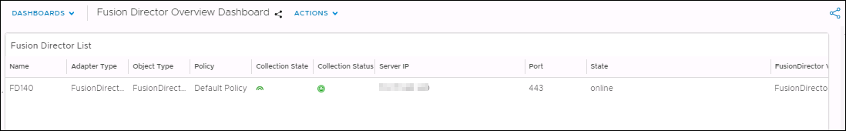

----End

Querying XFUSION Servers Overview Dashboard
            - On the vROps WebUI, choose Dashboards.
The Dashboards page is displayed.
            - In the navigation pane, choose Dashboards > XFUSION Servers Overview Dashboard.
The XFUSION Servers Overview Dashboard page is displayed.
You can view the following information, as shown in Figure 6-2.
- Servers Environment Health
- Servers Latest Alerts
- Top High Power Consumption Servers
- Top High Inlet Temperature Servers
- Top High Fan Speed On Average Servers
- Select About for Power Consumption Trend
- Select About for Temperature Trend
- Select About for Fan Speed Trend
              - XFUSION Servers Overview Dashboard
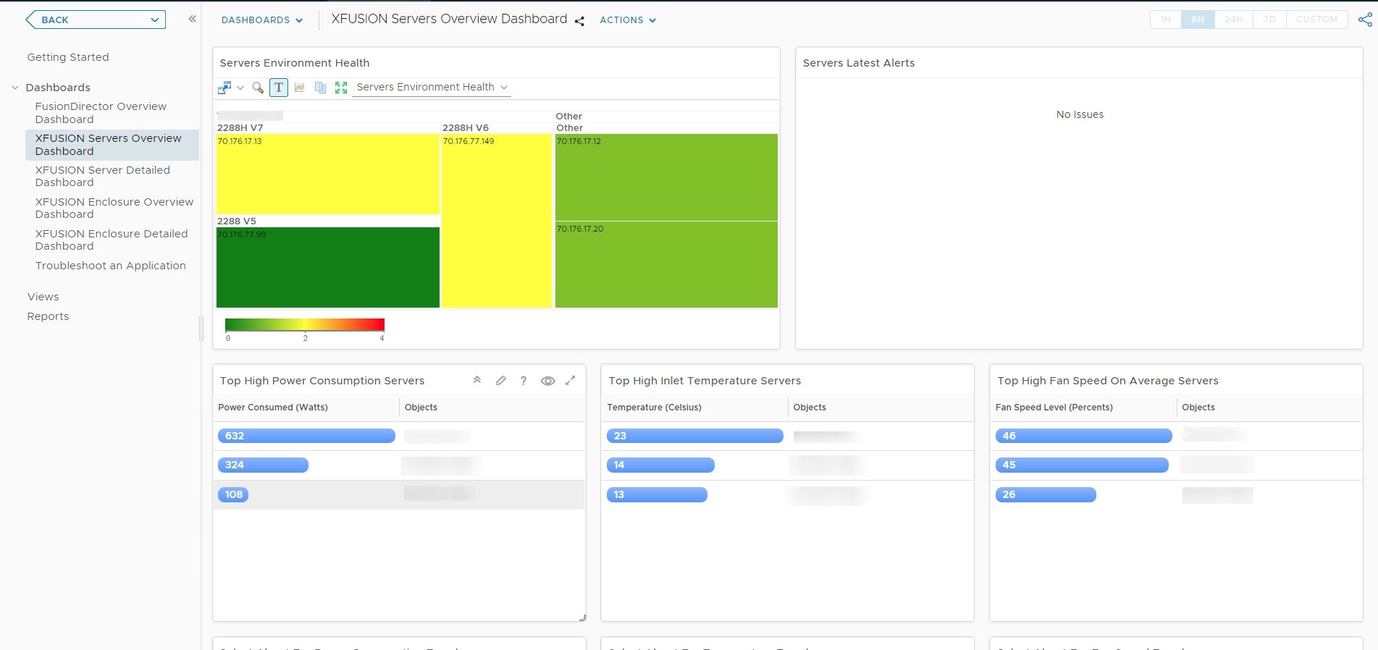

            - In the Servers Environment Heath area, select a server. You can view the latest alarms of the server in the Servers Latest Alerts area, as shown in Figure 6-3.
              - XFUSION Servers Latest Alerts
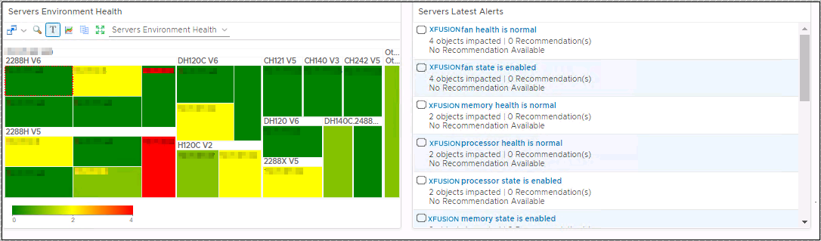

            - In the Top High Power Consumption Servers area, select different servers. You can view power consumption trends of these servers in the Select About For Power Consumption Trend area, as shown in Figure 6-4.
              - Power consumption trend
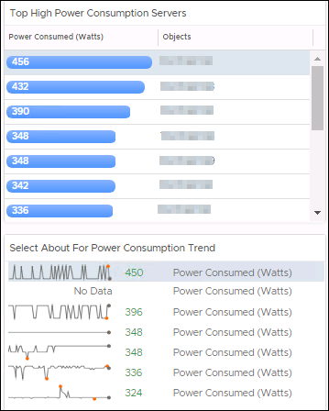

            - In the Top High Inlet Temperature Servers area, select different servers. You can view temperature trends of these servers in the Select About For Temperature Trend area, as shown in Figure 6-5.
              - Temperature trend
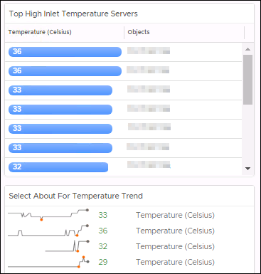

            - In the Top High Fan Speed On Average Servers area, select different servers. You can view fan speed trends of these servers in the Select About For Fan Speed Trend area, as shown in Figure 6-6.
              - Fan speed trend
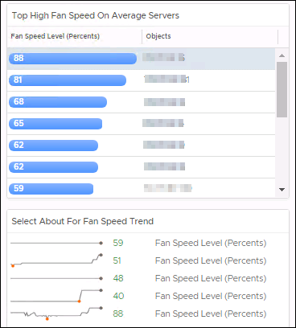

----End

Querying XFUSION Server Detailed Dashboard
            - On the vROps WebUI, choose Dashboards.
The Dashboards page is displayed.
            - In the navigation pane, choose Dashboards > XFUSION Server Detailed Dashboard.
The XFUSION Server Detailed Dashboard page is displayed.
            - In the XFUSION Server List area, select the server to be viewed.
You can view the following information, as shown in Figure 6-7.
- Object Relationship
- Latest Alerts
- Server Power Consumed Metric Chart
              - XFUSION Server Detailed Dashboard
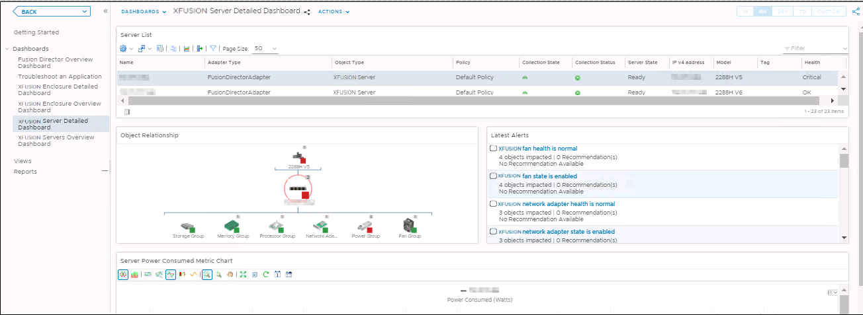

            - The server topology is displayed in the Object Relationship area. You can click any server or component to view the alerts and detailed information about the server or component, as shown in Figure 6-8.
              - Object Relationship
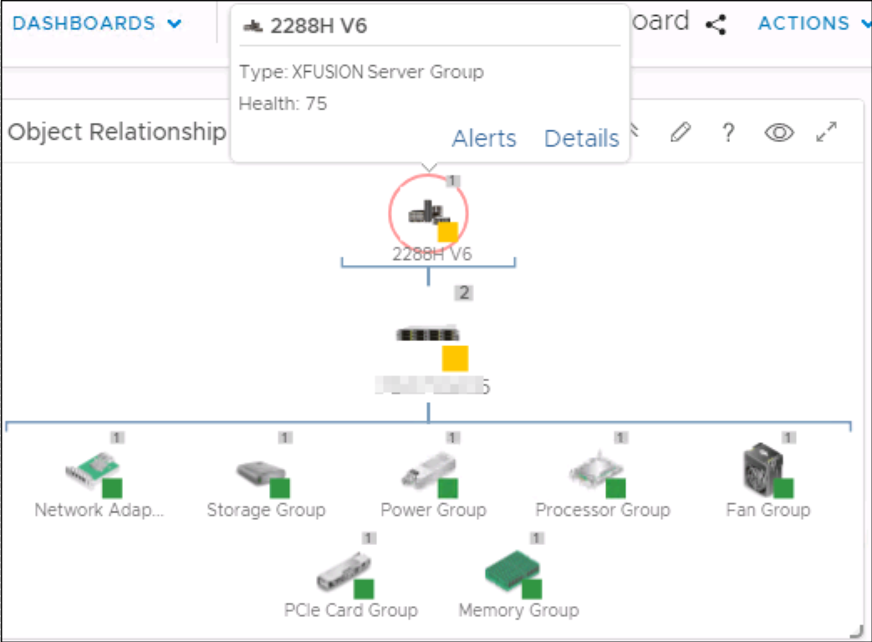

----End

Querying XFUSION Enclosure Overview Dashboard
            - On the vROps WebUI, choose Dashboards.
The Dashboards page is displayed.
            - In the navigation pane, choose Dashboards > XFUSION Enclosure Overview Dashboard.
The XFUSION Enclosure Overview Dashboard page is displayed.
You can view the following information, as shown in Figure 6-9.
- Enclosure Environment Health
- Enclosure Latest Alerts
              - XFUSION Enclosure Overview Dashboard
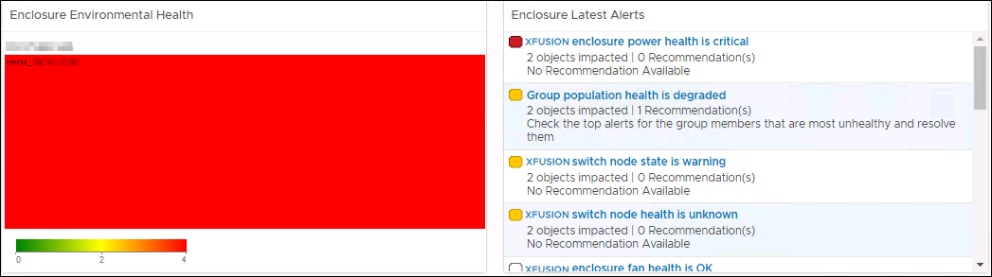

----End

Querying XFUSION Enclosure Detailed Dashboard
            - On the vROps WebUI, choose Dashboards.
The Dashboards page is displayed.
            - In the navigation pane, choose Dashboards > XFUSION Enclosure Detailed Dashboard.
The XFUSION Enclosure Detailed Dashboard page is displayed.
            - In the Enclosure List area, select the enclosure to be viewed.
You can view the following information, as shown in Figure 6-10.
- Latest Alerts
- Object Relationship
              - XFUSION Enclosure Detailed Dashboard
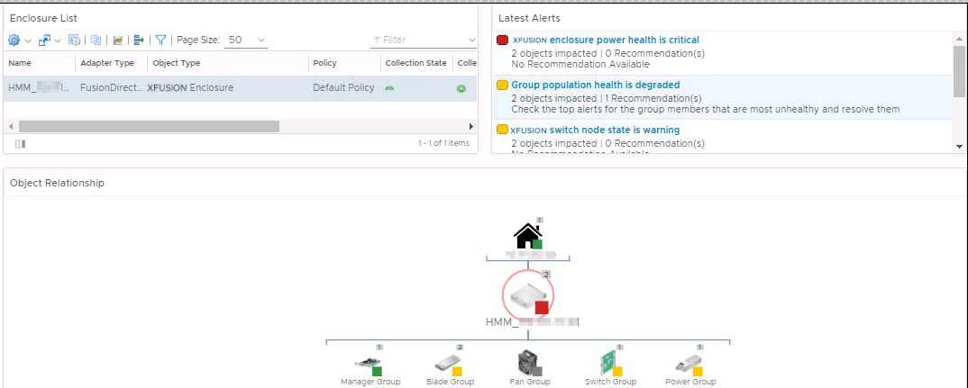

            - The enclosure topology is displayed in the Object Relationship area. You can click any enclosure or component to view the alerts and detailed information about the enclosure or component, as shown in Figure 6-11.
              - Object Relationship
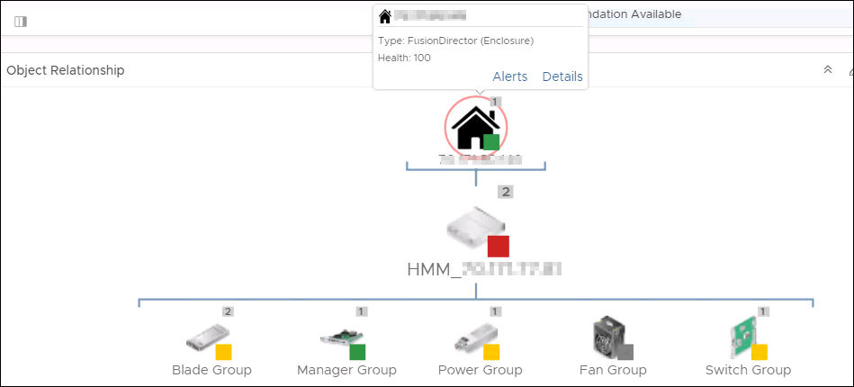

----End

Viewing Alerts
            - On the vROps WebUI, choose Alerts.
The Alerts page is displayed.
            - In the navigation pane, choose Triggered Alerts.
The Triggered Alerts page is displayed.
            - Select Object Type from the Group By drop-down list box.
            - In the alarm column of the component for which the alarm is generated, click to expand the list and click Triggered On, as shown in Figure 7-1.

You can only select a component, not a component group. Otherwise, the alerted server cannot be located.
              - All alerts
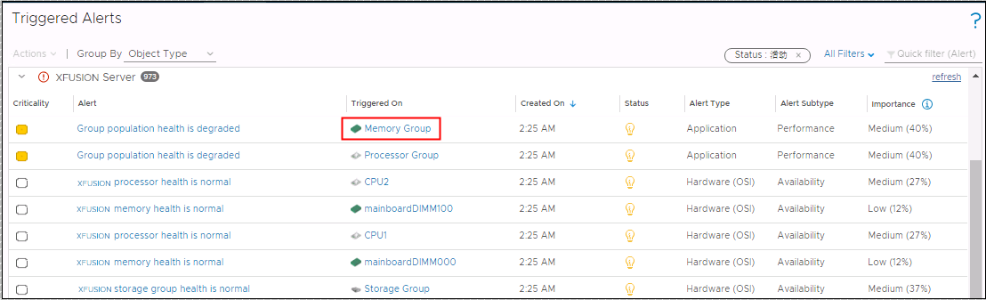

The page about the triggered object is displayed, as shown in Figure 7-2.
              - Triggered object
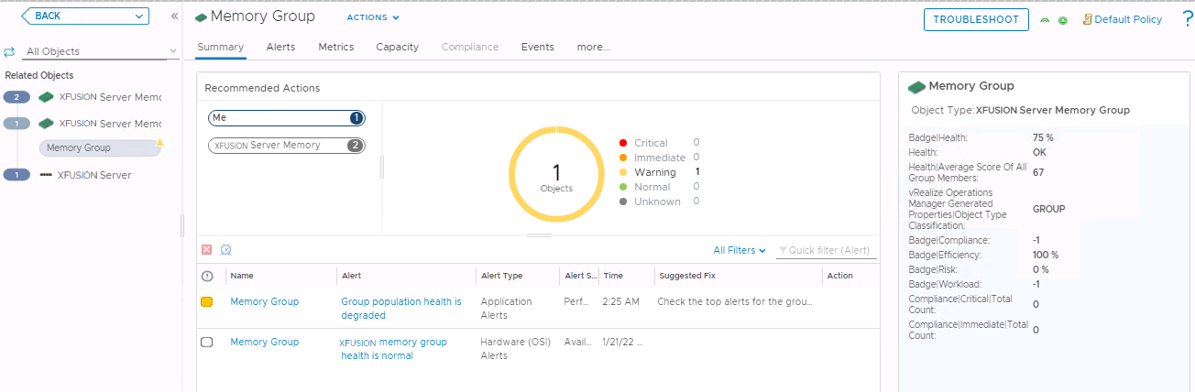

            - In the navigation tree on the left, click an object (such as XFUSION Server Group or XFUSION Server) to view the server to which the trigger object belongs.
----End

Querying the XFUSION vROps Plug-in Version
            - On the vROps WebUI, choose Administration.
The Administration page is displayed.
            - In the navigation pane on the left, choose Repository.
The Repository page is displayed.
            - Check the current version of the vROps plug-in, as shown in Figure 8-1.
              - Viewing the plug-in version
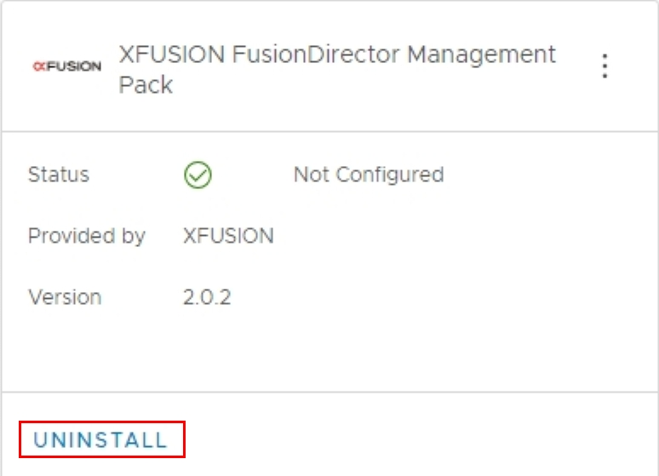

----End
- Obtaining Technical Support
To obtain assistance, contact technical support as follows:
- Contact customer service center at support@xfusion.com.
- Contact technical support personnel.
- Communication Matrix
Source Device | Source IP Address | Source Port Number | Destination Device | Destination IP Address | Destination Port Number | Protocol | Port Description | Destination Port Configurable | Authentication Mode | Encryption Mode
Device to which vRops belongs | IP address of the device to which vRops belongs | Random | Device to which FusionDirector belongs | IP address of the device to which FusionDirector belongs | 443 | TCP | HTTPS(Web)  HTTPS standard protocol port is enabled by default. Plug-in, as a client, accesses FusionDirector service. | No | Token | TLS
Client | Client IP address | Random | Device to which vRops belongs | IP address of the device to which vRops belongs | 44300-44399  Note: The port number ranges from 44300 to 44399. | TCP | The port that receives the report events of FusionDirector is enabled by default. | Yes | User name/ password | TLS

